Sport Organization’s for Placer County Area

By, Keith Anfinson - Adapted Physical Education Teacher
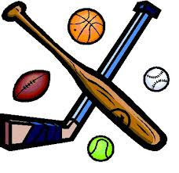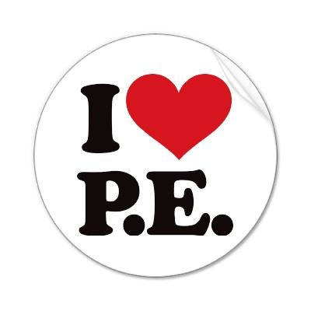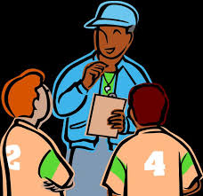

- Ability First Sports: a 501(C)(3) non-profit organization
  - www.abilityfirstsports.org
  - (530) 588-0335 in Chico, California
  - This is for children with physical disabilities.

Special Olympics in Northern California
Special Olympics Northern California provides athletic opportunities to children and adults with intellectual disabilities, instilling the confidence they need to succeed in life.
Core Values
- Sportsmanship — A commitment to fairness, ethics, respect, and fellowship in competition and in life. “Let me win, but if I cannot win, let me be brave in the attempt.”
- Volunteerism — A commitment to celebrating and appreciating volunteers, who do good for the benefit of others without seeking personal reward or remuneration.
- Acceptance — A commitment to openly embrace and welcome all others without regard to ability, race, creed, nationality, religion, age, gender or sexual orientation.
http://www.sonc.org

Access Dance Program
A program offering free creative movement classes designed especially for children with disabilities who may need special attention in order to fully experience the joy of movement, creative self-expression, and therapeutic benefits of dance.
The classes will now serve children ages 1-5 years and 6-18 years with disabilities such as autism, down syndrome and cerebral palsy. New class for ages 1-5 on Mondays, from 3:00-3:30 pm, and classes for ages 6-18 on Saturdays from 12:30-1:30 pm and 1:30 -2:30 pm.
Class sizes are limited and open to the first students to enroll in the program! Please call 916-791s-2061 for more information and to register
http://www.sassna.org/news/2014/8/26/access-dance-program
Access Leisure is a program of the City of Sacramento Department of Parks and Recreation. Access Leisure provides sports, residential camping and outdoor education as well as social and fitness programs for children, teens, and adults with disabilities

https://www.cityofsacramento.org/ParksandRec/Recreation/Special-Needs

﻿﻿﻿Welcome to Placer Foothills MTB C﻿lub
Placer Foothills MTB Club is dedicated to encouraging the riders in the Placer Foothills area to explore their love of mountain biking.
Riders of all levels and ages are welcome.
Come and join us!
http://www.placerfoothillsmtb.com

- ACHIEVE TAHOE (FORMERLY DISABLED SPORTS USA FAR WEST) Phone: (530) 581-4161 Address: 2680 Alpine Meadows Road Alpine Meadows, CA 96146 view map ADAPTIVE SNOW SPORTS: Our flagship program operates daily December through April at Alpine Meadows, Squaw Valley and Northstar resorts in Tahoe. Certified instructors and trained volunteers provide over 6,000 hours of instruction. Specialized adaptive equipment and teaching methods allow inclusion for all.
- http://achievetahoe.org

- RIDE TO WALK Phone: 916-791-2747 Address: 1630 Hwy 193 Lincoln, CA 95648 view map Ride To Walk (RTW) is a therapeutic horseback riding program founded by Dr. Kristine Corn in 1985. Its mission is to enhance the lives of children and young adults with neurological disabilities by providing innovative therapeutic horseback riding activities that are recreational in nature.
http://www.ridetowalk.org/Contact-Us.html
Speamps for Special Kids
A GUIDE TO SUMMER CAMPS FOR KIDS WITH SPECIAL NEEDS IN SOUTHERN CALIFORNIA
http://specialcampsforspecialkids.com

iCan Bike – Yuba City, CA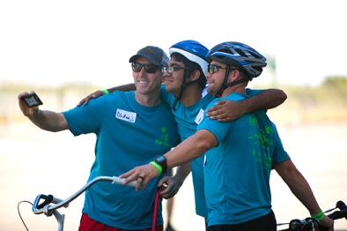
We understand that the vast majority of people with disabilities never have the experience of independently riding a conventional two-wheel bicycle during their lifetime. Research shows that over 80% of people with Autism and 90% of people with Down syndrome never experience this thrill. Defying these odds is why we exist!
http://icanshine.org/yuba-city-ca/

